Eyeconic - Glasses Shop Management System

Category

Version 1.0

Revision History

|  |  |  |  |
| --- | --- | --- | --- |
| **Date** | **Version** | **Description** | **Author** |
| 20/11/2019 | 1.0 | The first version of edit category | Hoàng Tiến Long |

Table of Contents

1. Introduction 4

1.1 Purpose 4

1.2 Scope 4

1.3 Definitions, Acronyms, and Abbreviations 4

1.4 References 4

1.5 Overview 4

2. Flow of Events—Design 4

3. Derived Requirements 6

# Introduction

## Purpose

This document describes how the Edit Category use case is realized within the design model.

## Scope

This document applies to the Eyeconic - Glasses Shop Management System.

## Definitions, Acronyms, and Abbreviations

None.

## References

None.

## Overview

In the following section, Use-Case Realization Specification of the Edit Category use-case of the Eyeconic is provided in detail. The first section is a textual description of the Use-Case specification. The following section contains sequence diagrams describing how the use case is realized in terms of collaborating objects. The third section includes class diagrams with relationships that participate in the realization of the use case. The last section is an analysis of all requirements, such as non-functional requirements, on the use-case realization that are not considered in the design model, but that need to be taken care of during implementation.

# Flow of Events—Design

**2.1. Use-Case Specification**

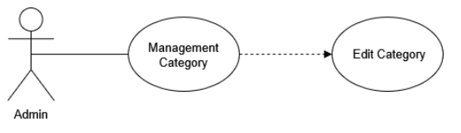

|  |  |  |  |
| --- | --- | --- | --- |
| **Name** | | | Edit Category |
| **Brief Dexcription** | | | Administrator edits new categories into the website. |
| **Actors** | | | Administrator |
| **Flow of Events** | | | |
| **Basic Flow** | | | |
| Step 1: Click edit a new category button in category management.  Step 2: Enter changing category’s information.  Step 3: Set the database parameters of edited category.  Step 4: System displays edited category in the website. | | | |
| **Alternative Flows** | | | |
| **Title** | | **Description** | |
| Invalid information entered | | 1. Administrator enters invalid information.  2. System displays information with appropriate message to correct invalid information. | |
| **Pre-Conditions** | | | |
| The edited category had not existed in the database before. | | | |
| **Post-Condition**  Administrator checks the database and the website to ensure that the new category is edited successfully. | | | |
| **Title** | **Description** | | |
| Success | Success message is prompted and the category is edited to database. | | |
| Failure | The admin is unable to edit new category to database for one or more reasons and an error is prompt. | | |
| **Extension Points** | None | | |

**2.2. Sequence Diagram**

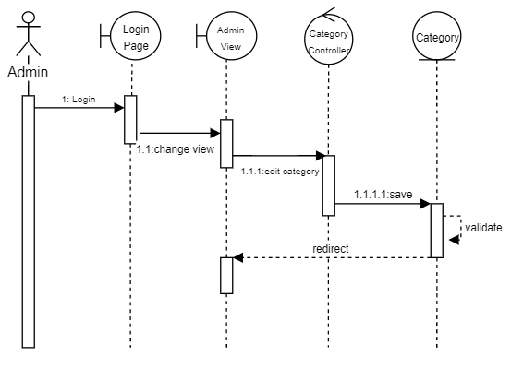

**2.3. Class Diagram**

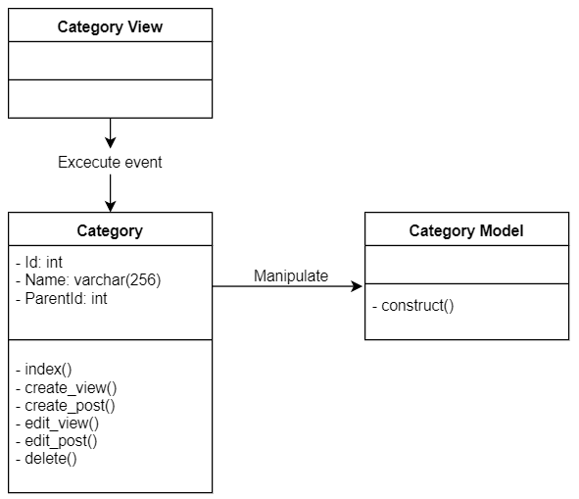

# Derived Requirements

None.